411b 50th Street east
Saskatoon, Sk
1-306-934-7665

Phone 1-866-934-7664
Email northendbus@sasktel.net

Thomas Seat back Foam 85461633 $45.00ea
Must purchase min of 5
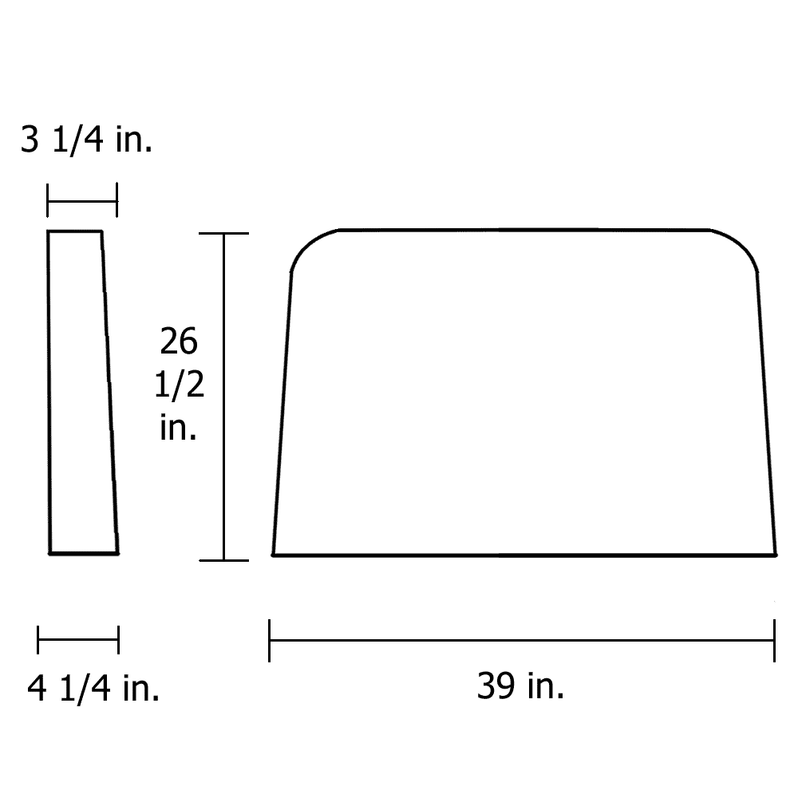
Caterpillar 37MT Starter $375ea while qty’s last
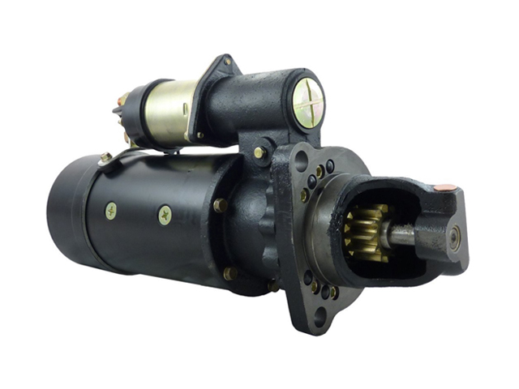
Caterpillar 41MT Starter $355.00ea while qty’s last

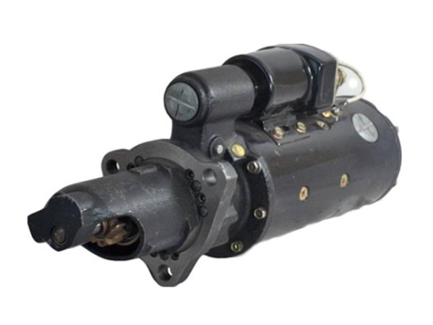

Phone 1-866-934-7664
Email northendbus@sasktel.net

