BOOSTER PUMPS

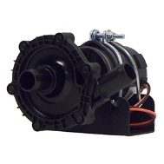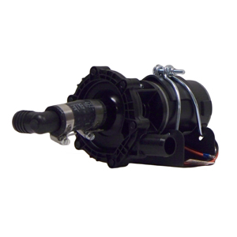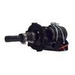
NEKY1099305 24V NEKY1099326 (1099306) 12V NEKY1099307 12V
FREIGHTLINER BSM1000368102 BLUE BIRD 10035131 BLUEBIRD 10033362
INTERNATIONAL ZGG734005 FREIGHTLINER BSM100036039, BSM1001487644 FREIGHTLINER BSM1000368103
INTERNATIONAL 2614948C91 INTERNATIONAL ZGG73400

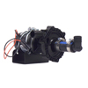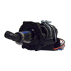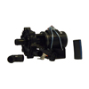
NEKY1099308 12V NEKY1099309 12V NEKY1099311 (UNIVERSAL)
BLUEBIRD 10034148 FREIGHTLINER BSM1000368105 INTERNATIONAL ZGG734010
INTERNATIONAL ZGG734007 INTERNATIONAL ZGG734008

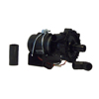
NEKY1099312 (UNIVERSAL)
INTERNATIONAL ZGG734011

